**SOFTWARE DESIGN DOCUMENT (SDD)**

## Vehicle Service Management System

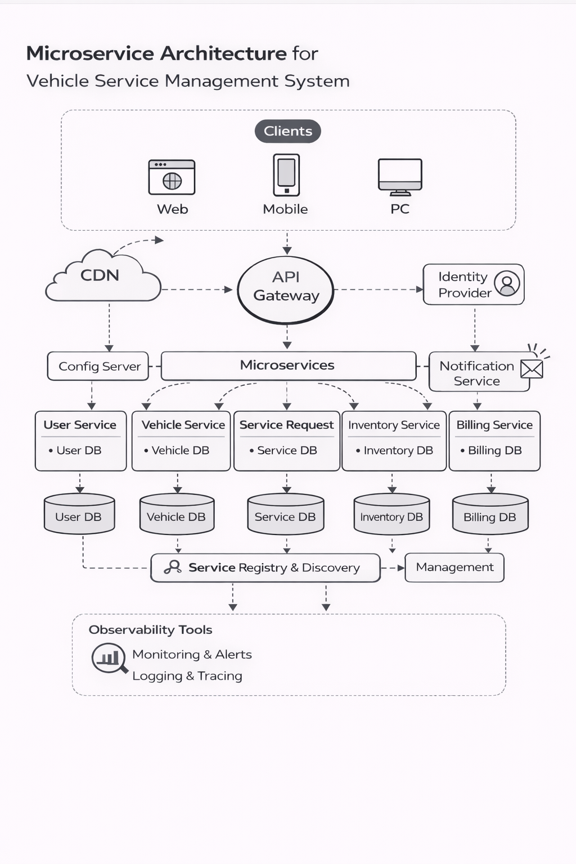

## 

## 1. DOCUMENT CONTROL

| **Item** | **Details** |
| --- | --- |
| Project Name | Vehicle Service Management System |
| Version | 1.0 |
| Author | (Maddha Sharanya) |
| Date | (Date) |
| Status | Final |

## 2. PURPOSE OF THE DOCUMENT

This document describes the **system architecture, design decisions, component structure, APIs, data models, and non-functional aspects** of the Vehicle Service Management System.

It is intended for:

* Developers
* Reviewers
* Interview discussions
* Maintenance & enhancement planning

## 3. SYSTEM OVERVIEW

**Business Objective**

Provide a scalable, secure, and maintainable system to:

* Manage users
* Manage vehicles
* Manage service requests
* Manage spare parts inventory and billing

**High-Level Features**

* User registration & login
* Role-based access (Customer / Technician / Manager / Admin)
* Vehicle management and service booking
* Service lifecycle tracking
* Technician assignment and workload management

## 

## 

## 4. ARCHITECTURE OVERVIEW (HLD)

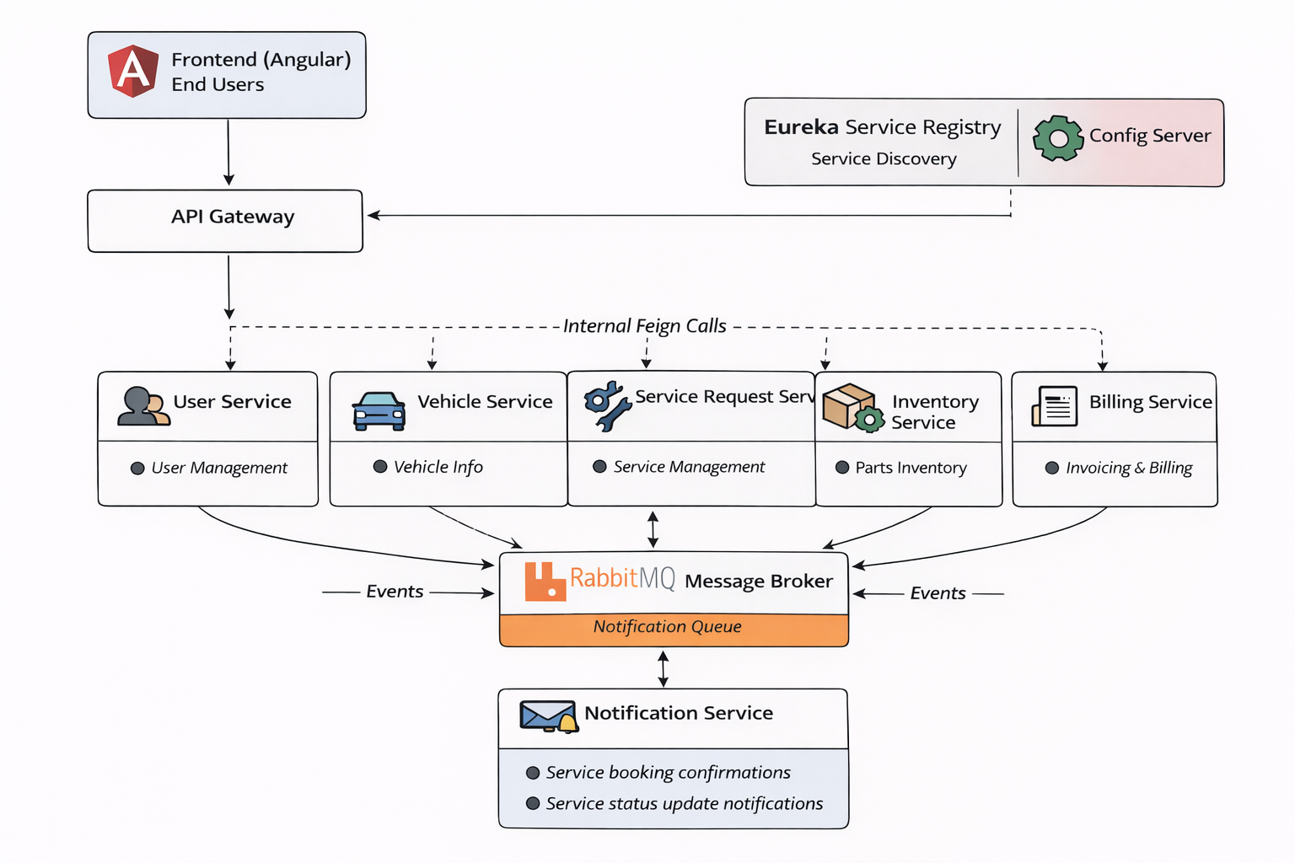

**Architecture Style**

* Microservices Architecture
* REST-based communication
* Containerized deployment

**Core Components**

1. Angular Frontend
2. API Gateway
3. User Service
4. Service request Service
5. Vehicle Service
6. Inventory Service
7. Billing Service
8. Notification Service
9. MongoDB (per service)
10. Eureka Server
11. Config Server
12. CI/CD Pipeline

## 5. TECHNOLOGY STACK

**Backend**

* Java 17
* Spring Boot
* Spring Web
* Spring Data MongoDB
* Spring Validation

**Frontend**

* Angular
* Angular Material
* RxJS

**Database**

* MongoDB (one DB per microservice)

**DevOps**

* Docker
* Docker Compose
* Jenkins
* SonarQube

**Testing**

* JUnit 5
* Mockito
* Spring Boot Test
* Jasmine / Karma

## 6. MICROSERVICES DESIGN

**6.1 User Service**

**Responsibilities**

* User registration (customers only)
* Authentication using JWT
* Role management (ADMIN, MANAGER, TECHNICIAN, CUSTOMER)
* Enable / Disable users
* Technician profile & workload tracking

**APIs**

POST /api/auth/register  
POST /api/auth/login

POST /api/users/internal/create

GET /api/users

GET /api/users/role/{role}

PATCH /api/users/{id}/enable

PATCH /api/users/{id}/disable

PATCH /api/users/technicians/{id}/increment

PATCH /api/users/technicians/{id}/decrement

**Database**

* users collection
* technicians collection

**6.2 Vehicle Service**

**Responsibilities**

* Register customer vehicles
* Fetch customer vehicles
* Delete vehicles

**APIs**

POST /api/vehicles

GET /api/vehicles/customer/{customerId}

DELETE /api/vehicles/{vehicleId}

**Database**

* products collection

**6.3 Service Request Service**

**Responsibilities**

* Create service requests
* Assign technician & service bay
* Manage service lifecycle (REQUESTED → ASSIGNED → IN_PROGRESS → COMPLETED → CLOSED)
* Handle parts request & approval
* Trigger billing & inventory deduction
* Publish service status notifications

**APIs**

POST /api/service-requests

GET /api/service-requests/customer/{customerId}

GET /api/service-requests/manager

GET /api/service-requests/technician/{technicianId}

PATCH /api/service-requests/{id}/assign

PATCH /api/service-requests/{id}/status

POST /api/service-requests/{id}/parts/request

PATCH /api/service-requests/{id}/parts/approve

**Database**

* service_requests collection
* service_bays collection

**6.4 Inventory Service**

**Responsibilities**

* Maintain spare parts inventory
* Deduct stock during service
* Provide low-stock alerts
* Fetch part details

**APIs**

POST /api/parts

GET /api/parts

GET /api/parts/{id}

POST /api/parts/deduct

GET /api/parts/alerts/low-stock

**Database**

* inventory_parts collection

**6.5 Billing Service**

**Responsibilities**

* Generate invoice after service closure
* Calculate service cost using inventory & service request data
* Fetch customer invoices

**APIs**

POST /api/invoices/generate/{serviceRequestId}

GET /api/invoices/customer/{customerId}

**Database**

* invoices collection

## 7. DATA DESIGN (LLD)

**User Document**

{

"id": "u101",

"username": "Sharanya",

"email": "user@test.com",

"password": "encrypted_password",

"role": "CUSTOMER",

"active": true,

"createdAt": "2026-01-01T10:00:00"

}

**Technician Document**

{

"id": "t201",

"userId": "u102",

"specialization": "ENGINE",

"workload": 2,

"active": true

}

**Vehicle Document**

{

"id": "v301",

"customerId": "u101",

"registrationNumber": "KA01AB1234",

"make": "Honda",

"model": "City",

"year": 2022,

"vehicleType": "CAR",

"color": "White"

}

**Service Request Document**

{

"id": "sr401",

"requestNumber": "SR-2AF19C",

"customerId": "u101",

"vehicleId": "v301",

"technicianId": "t201",

"bayNumber": 3,

"priority": "HIGH",

"issue": "Engine overheating",

"status": "IN_PROGRESS",

"usedParts": [

{ "partId": "p501", "qty": 2 }

],

"partsStatus": "PARTS_ISSUED",

"createdAt": "2026-01-01T11:00:00",

"version": 1

}

**Inventory Part Document**

{

"id": "p501",

"name": "Oil Filter",

"price": 500,

"stock": 50,

"reorderLevel": 10

}

**Invoice Document**

{

"id": "i601",

"serviceRequestId": "sr401",

"customerId": "u101",

"total": 3500,

"status": "PENDING",

"generatedAt": "2026-01-01T14:00:00"

}

**Service Bay Document**

{

"id": "b701",

"bayNumber": 3,

"available": false

}

## 8. API DESIGN & VALIDATION

* RESTful principles
* JSON request/response
* Bean Validation at DTO layer
* Service-level business rule enforcement
* Standard HTTP status codes

## 9. ERROR HANDLING STRATEGY

**Global Exception Handling**

* Centralized using @ControllerAdvice
* Standard error response format

{

"timestamp": "2025-01-01T10:00:00",

"status": 400,

"error": "Validation Error",

"message": "Price must be greater than zero"

}

## 10. SECURITY DESIGN

* Password encryption (BCrypt)
* Role-based access control
* JWT authentication (optional enhancement)
* Secure API access

## 11. NON-FUNCTIONAL REQUIREMENTS

| **Area** | **Design Decision** |
| --- | --- |
| Scalability | Stateless services, Docker |
| Performance | Pagination, async calls |
| Availability | Independent services |
| Maintainability | POM-like layered backend |
| Security | Validation, encryption |
| Observability | Logging & monitoring |

## 12. TESTING STRATEGY



**Backend**

* Unit tests (Service layer)
* Controller tests (MockMvc)
* Minimum 90% coverage

**Frontend**

* Component tests
* Service tests

**Quality Gates**

* SonarQube enforced
* Build fails on violations

## 13. CI/CD DESIGN





**Pipeline Flow**

1. Git Commit
2. Jenkins Build
3. Unit Tests
4. SonarQube Scan
5. Quality Gate Check
6. Docker Build
7. Docker Compose Deploy

## 14. DEPLOYMENT DESIGN

* Docker image per microservice
* docker-compose for orchestration
* Environment-specific configs

## 15. ASSUMPTIONS & CONSTRAINTS

**Assumptions**

* Services communicate over REST
* MongoDB available
* Docker environment present

**Constraints**

* No distributed transactions
* Event-driven architecture out of scope

## 16. FUTURE ENHANCEMENTS

* Spring Cloud Gateway
* Kafka-based async communication
* Kubernetes deployment
* Centralized logging (ELK)

## 17. CONCLUSION

This design ensures:  
✔ Clean separation of concerns  
✔ Scalability & maintainability  
✔ Testability & CI/CD readiness  
✔ Interview-ready explanation

# 

# 

# 

# 

# 

# 

# SEQUENCE DIAGRAMS — VEHICLE SERVICE MANAGEMENT SYSTEM

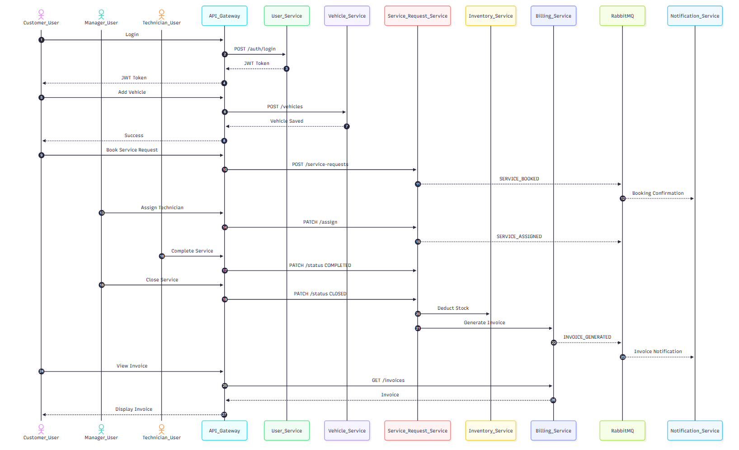

## 1. User Registration — Sequence Diagram

**Scenario**

A new user registers using the Angular UI.

**Flow**

1. User enters details in Angular UI
2. Angular sends POST /api/auth/register to API Gateway
3. API Gateway routes request to User Service
4. User Service validates request (email, password)
5. User Service checks email uniqueness in MongoDB
6. Password is encrypted
7. User is saved in MongoDB
8. Success response sent back to UI

**Participants**

* User
* Angular UI
* API Gateway
* User Service
* MongoDB

**Key Design Points**

* Validation at API boundary
* Encryption at service layer
* No direct DB access from UI

## 2. User Login — Sequence Diagram

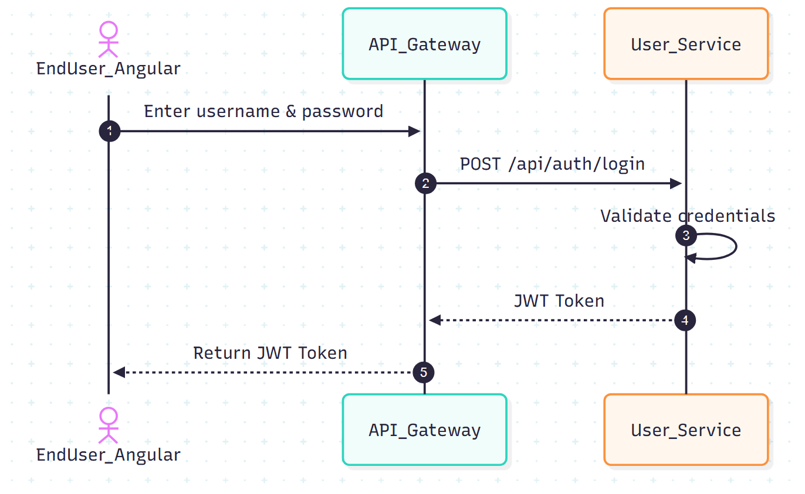



**Scenario**

A registered user logs into the system.

**Flow**

1. User submits login form
2. Angular calls POST /api/auth/login
3. API Gateway routes request to User Service
4. Password is verified
5. JWT token generated
6. Response sent to Angular

**Participants**

* User
* Angular UI
* API Gateway
* User Service
* MongoDB

### Key Design Points

* Stateless authentication using JWT
* Token-based authorization

**Failure Cases**

* Invalid credentials → 401
* Inactive user → 403

## 3. Vehicle Registration — Sequence Diagram

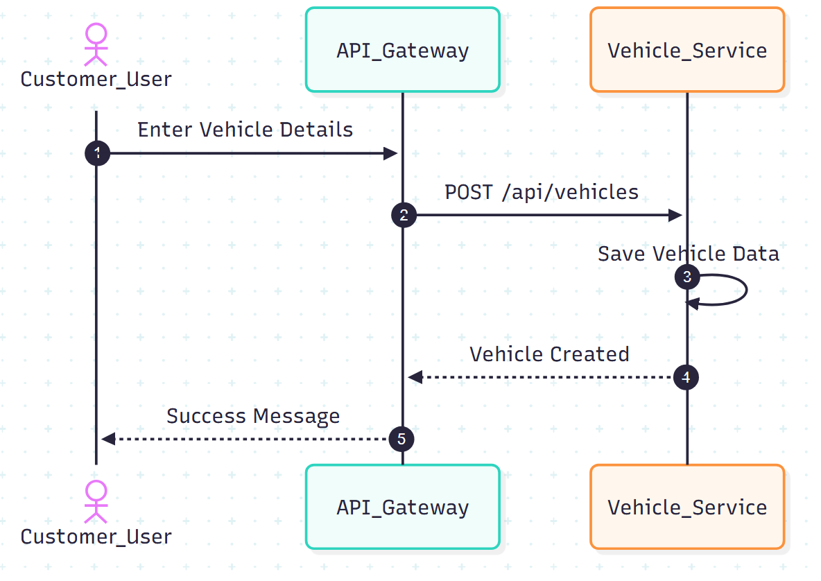



**Scenario**

Customer registers a vehicle.

**Flow**

1. Customer enters vehicle details

2. Angular sends POST /api/vehicles to API Gateway

3. API Gateway validates token

4. Password is verified

5. Vehicle Service saves vehicle details in MongoDB

6. Success response returned

**Participants**

* Customer
* Angular UI
* API Gateway
* Vehicle Service
* MongoDB

**Failure Cases**

* Invalid credentials → 401
* Inactive user → 403

## 4. Service Booking — Sequence Diagram

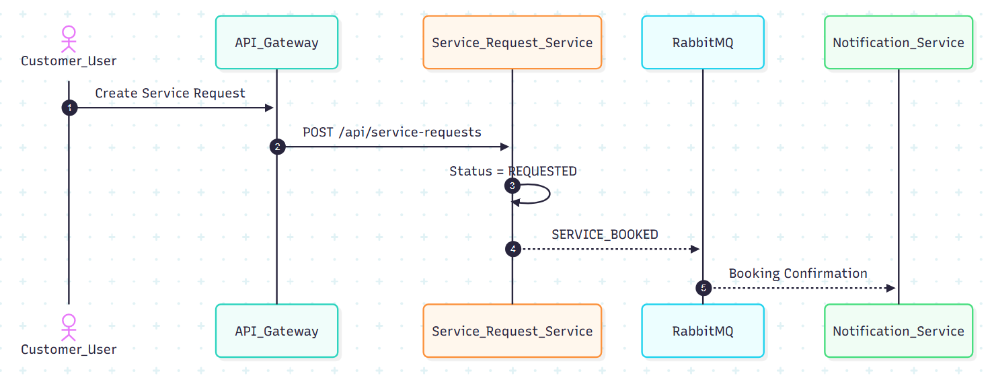

**Scenario**

Customer books a service request.

**Flow**

1. Customer enters service issue
2. Angular sends POST /api/service-requests
3. API Gateway routes to Service Request Service
4. Service Request created with status REQUESTED
5. SERVICE_BOOKED event published to RabbitMQ
6. Notification Service sends confirmation

**Participants**

* Customer
* Angular UI
* API Gateway
* Service Request Service
* RabbitMQ
* Notification Service

**Failure Cases**

* Invalid credentials → 401
* Inactive user → 403

## 4. Service Request Management — Sequence Diagram

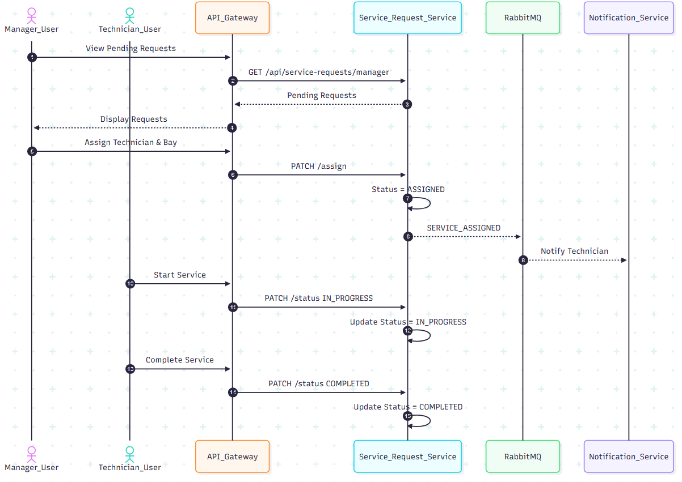

**Scenario**

Manager assigns technician and technician completes service.

**Flow**

1. Manager fetches pending requests
2. Manager assigns technician & bay
3. Status updated to ASSIGNED
4. Technician updates status to IN_PROGRESS
5. Technician completes job → status COMPLETED

**Participants**

* Manager
* Technician
* Angular UI
* API Gateway
* Service Request Service

### Key Design Points

* Optimistic locking
* Role based access control

## 5. Invoice Generation — Sequence Diagram

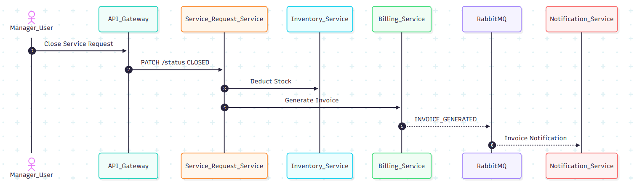

**Scenario**

Manager closes service & invoice is generated.

**Flow**

1. Manager closes service
2. Service Request Service deducts inventory
3. Billing Service calculates cost
4. Invoice stored in MongoDB
5. INVOICE_GENERATED event sent
6. Customer receives notification

**Participants**

* Manager
* Angular UI
* API Gateway
* Service Request Service
* Inventory Service
* Billing Service
* Notification Service

**Key Design Decisions**

* Inter-service communication using Feign
* Billing only after service closure

## 6. CI/CD Pipeline — Sequence Diagram





**Scenario**

Developer pushes code to Git repository.

**Flow**

1. Developer pushes code
2. Jenkins pipeline triggered
3. Jenkins runs unit tests
4. Jenkins runs SonarQube scan
5. Quality gate checked
6. Docker images built
7. Docker Compose deploys services

**Participants**

* Developer
* Git
* Jenkins
* SonarQube
* Docker

## 7. Error Handling — Sequence Diagram

**Scenario**

Invalid request sent to backend.

**Flow**

1. Angular sends invalid request
2. Controller validation fails
3. Global exception handler triggered
4. Standard error response returned

**Key Point**

* Consistent error structure across services

**HOW TO EXPLAIN IN INTERVIEWS**

“We use sequence diagrams to show runtime behavior.  
Each diagram highlights service boundaries, validation points, and data ownership, ensuring clean microservices communication.”

**----- upto here ------**

# SEQUENCE → CODE CLASS MAPPING

**1) User Registration**

**Sequence Steps**

1. User submits registration form
2. API receives request
3. Validate input & business rules
4. Encrypt password
5. Persist user
6. Return response

**Code Mapping (User Service)**

| **Step** | **Layer** | **Class** | **Responsibility** |
| --- | --- | --- | --- |
| 1 | Angular | RegisterComponent | Collect form data |
| 2 | Angular | AuthService | POST /users/register |
| 3 | API | AuthController | Request mapping |
| 4 | DTO | UserRegisterRequest | Bean validation |
| 5 | Service | UserServiceImpl | Uniqueness checks |
| 6 | Security | PasswordEncoderConfig | BCrypt encryption |
| 7 | Repo | UserRepository | Save user |
| 8 | API | AuthController | Return response |

**Key Methods**

* UserController.register(UserRegisterRequest)
* UserService.registerCustomer(...)
* UserRepository.existsByEmail(...)

**2) User Login**

**Sequence Steps**

1. User submits login form
2. Validate credentials
3. Generate JWT token
4. Return token

**Code Mapping**

| **Step** | **Layer** | **Class** | **Responsibility** |
| --- | --- | --- | --- |
| 1 | Angular | LoginComponent | Capture credentials |
| 2 | Angular | AuthService | POST /users/login |
| 3 | API | AuthController | Handle login |
| 4 | Repo | UserRepository | Find by email |
| 5 | Service | AuthService | Password match |
| 6 | Security | JwtTokenProvider | Create JWT |
| 7 | API | AuthController | Return token |

**Key Methods**

* AuthController.login(LoginRequest)
* UserService.login(...)

**3) Vehicle Registration**

**Sequence Steps**

1. Customer submits vehicle details
2. Validate ownership
3. Persist vehicle

**Code Mapping (Product Service)**

| **Step** | **Layer** | **Class** | **Responsibility** |
| --- | --- | --- | --- |
| 1 | Angular | AddVehicleComponent | Load products |
| 2 | Angular | VehicleService | POST/api/vehicles |
| 3 | API | VehicleController | Request Mapping |
| 4 | DTO | ProductService | Bean validation |
| 5 | Service | ProductRepository | Map DTO to entity |
| 6 | Repo | VehicleRepository | Save Vehicle |

**Key Methods**

* VehicleController.create(VehicleRequest)
* VehicleService.addVehicle(...)

**4) Service Booking**

**Sequence Steps**

1. Customer submits service issue
2. Create service request
3. Publish booking event

**Code Mapping (Service Request Services)**

| **Step** | **Layer** | **Class** | **Responsibility** |
| --- | --- | --- | --- |
| 1 | Angular | BookServiceComponent | Collect issue |
| 2 | Angular | ServiceRequestService | POST /api/service-requests |
| 3 | API | ServiceRequestController | Request mapping |
| 4 | DTO | ServiceRequestCreateDTO | Validate input |
| 5 | Service | ServiceRequestServiceImpl | Create service request |
| 6 | Repository | ServiceRequestRepository | Save request |
| 7 | Messaging | RabbitPublisher | Publish SERVICE_BOOKED |
|  |  |  |  |
|  |  |  |  |
|  |  |  |  |

**Key Methods**

* ServiceRequestController.create()
* ServiceRequestServiceImpl.createRequest()

**5) Service Management**

**Sequence Steps**

1. Manager assigns technician
2. Technician updates status
3. Manager closes service

**Code Mapping**

| **Step** | **Layer** | **Class** | **Responsibility** |
| --- | --- | --- | --- |
| 1 | Angular | ManagerDashboard | Fetch pending requests |
| 2 | Angular | ServiceRequestService | PATCH /assign/{id} |
| 3 | API | ServiceRequestController | Request mapping |
| 4 | DTO | AssignTechnicianDTO | Validate request |
| 5 | Service | ServiceRequestServiceImpl | Assign technician |
| 6 | Repository | ServiceRequestRepository | Save changes |

**Key Methods**

* assignTechnician(id,dto)
* updateStatus(id,dto)

**6) Invoice Generation**

**Sequence Steps**

1. Manager closes service
2. Deduct inventory
3. Generate invoice

**Code Mapping**

| **Step** | **Layer** | **Class** | **Responsibility** |
| --- | --- | --- | --- |
| 1 | Angular | BillingComponent | Trigger invoice |
| 2 | Angular | BillingService | POST /api/invoices/generate/{id} |
| 3 | API | BillingController | Request mapping |

**Key Classes**

* BillingController.generate()
* BillingServiceImpl.generateInvoice()

**7) CI/CD with SonarQube**

**Sequence Steps**

1. Git push
2. Build & tests
3. Sonar scan
4. Quality gate
5. Docker build
6. Deploy

**Code/Config Mapping**

| **Step** | **Tool** | **File/Class** |
| --- | --- | --- |
| 1 | Git | Repository |
| 2 | Jenkins | Jenkinsfile |
| 3 | Maven | pom.xml |
| 4 | SonarQube | sonar-project.properties |
| 5 | Docker | Dockerfile |
| 6 | Compose | docker-compose.yml |

**TRACEABILITY (WHY THIS MATTERS)**

* **Sequence step** → **Controller** → **Service** → **Repository**
* Every **business rule** is enforced **either in DTO validation or service logic**
* Easy to explain **end-to-end flow** in interviews

**How to explain succinctly**

“Each sequence diagram step maps directly to a controller endpoint, a service orchestration method, and a repository call. Validation is enforced at DTO and service layers, and failures are handled centrally.”

**CODE SKELETON — PACKAGES & CLASSES**

**1. USER SERVICE (user-service)**

user-service

└─ src/main/java/com/example/user

├─ UserServiceApplication.java

│

├─ controller

│ └─ UserController.java

│

├─ service

│ ├─ UserService.java

│ └─ UserServiceImpl.java

│

├─ repository

│ └─ UserRepository.java

│

├─ model

│ └─ User.java

│

├─ dto

│ ├─ UserRegisterRequest.java

│ ├─ LoginRequest.java

│ └─ UserResponse.java

│

├─ exception

│ ├─ UserNotFoundException.java

│ ├─ DuplicateUserException.java

│ └─ GlobalExceptionHandler.java

│

└─ config

└─ SecurityConfig.java

**Key Responsibilities**

* UserController → API layer
* UserService → Business rules
* UserRepository → MongoDB access
* SecurityConfig → Password encoding / JWT (optional)

**2. PRODUCT SERVICE (product-service)**

product-service

└─ src/main/java/com/example/product

├─ ProductServiceApplication.java

│

├─ controller

│ └─ ProductController.java

│

├─ service

│ ├─ ProductService.java

│ ├─ ProductServiceImpl.java

│ └─ InventoryService.java

│

├─ repository

│ └─ ProductRepository.java

│

├─ model

│ └─ Product.java

│

├─ dto

│ ├─ ProductRequest.java

│ └─ ProductResponse.java

│

└─ exception

├─ ProductNotFoundException.java

└─ GlobalExceptionHandler.java

**Key Responsibilities**

* InventoryService → Stock validation & update
* ProductServiceImpl → Core business logic

**3. ORDER SERVICE (order-service)**

order-service

└─ src/main/java/com/example/order

├─ OrderServiceApplication.java

│

├─ controller

│ └─ OrderController.java

│

├─ service

│ ├─ OrderService.java

│ ├─ OrderServiceImpl.java

│ └─ OrderStatusValidator.java

│

├─ client

│ ├─ ProductClient.java

│ └─ UserClient.java

│

├─ repository

│ └─ OrderRepository.java

│

├─ model

│ ├─ Order.java

│ └─ OrderItem.java

│

├─ dto

│ ├─ OrderRequest.java

│ ├─ OrderItemRequest.java

│ └─ OrderResponse.java

│

└─ exception

├─ OrderNotFoundException.java

└─ GlobalExceptionHandler.java

**Key Responsibilities**

* ProductClient → Calls Product Service
* OrderStatusValidator → Valid status transitions
* OrderServiceImpl → Orchestrates order flow

**4. COMMON / SHARED CONCEPTS (Optional)**

common

└─ src/main/java/com/example/common

├─ exception

│ └─ ApiErrorResponse.java

│

├─ util

│ └─ Constants.java

│

└─ config

└─ SwaggerConfig.java

**5. ANGULAR FRONTEND (angular-ui)**

angular-ui

└─ src/app

├─ core

│ ├─ services

│ │ ├─ auth.service.ts

│ │ ├─ product.service.ts

│ │ └─ order.service.ts

│ │

│ └─ guards

│ └─ auth.guard.ts

│

├─ modules

│ ├─ auth

│ │ ├─ login.component.ts

│ │ └─ register.component.ts

│ │

│ ├─ product

│ │ └─ product-list.component.ts

│ │

│ └─ order

│ ├─ checkout.component.ts

│ └─ order-history.component.ts

│

├─ shared

│ └─ models

│ ├─ user.model.ts

│ ├─ product.model.ts

│ └─ order.model.ts

│

└─ app.module.ts

**6. TEST STRUCTURE (IMPORTANT)**

src/test/java

└─ com/example

├─ controller

│ └─ UserControllerTest.java

├─ service

│ ├─ UserServiceTest.java

│ └─ OrderServiceTest.java

└─ repository

└─ ProductRepositoryTest.java

**7. DEVOPS & CI/CD FILES**

capstone-project

├─ Jenkinsfile

├─ docker-compose.yml

├─ user-service/Dockerfile

├─ product-service/Dockerfile

├─ order-service/Dockerfile

├─ angular-ui/Dockerfile

└─ README.md

**HOW TO EXPLAIN THIS IN INTERVIEWS**

“Each microservice follows a layered architecture: Controller → Service → Repository.  
Clients handle inter-service communication.  
DTOs isolate API contracts.  
Business rules live in the service layer.  
This makes the system scalable, testable, and maintainable.”

**STARTER REPO**







**1. REPOSITORY STRUCTURE (ROOT)**

smart-order-management/

│

├─ user-service/

├─ product-service/

├─ order-service/

├─ angular-ui/

│

├─ common/

│

├─ docker-compose.yml

├─ Jenkinsfile

├─ .gitignore

├─ README.md

You can create this repo **as-is** in GitHub.

**2. USER SERVICE (Spring Boot)**

user-service/

├─ src/main/java/com/example/user

│ ├─ UserServiceApplication.java

│ │

│ ├─ controller

│ │ └─ UserController.java

│ │

│ ├─ service

│ │ ├─ UserService.java

│ │ └─ UserServiceImpl.java

│ │

│ ├─ repository

│ │ └─ UserRepository.java

│ │

│ ├─ model

│ │ └─ User.java

│ │

│ ├─ dto

│ │ ├─ UserRegisterRequest.java

│ │ ├─ LoginRequest.java

│ │ └─ UserResponse.java

│ │

│ ├─ exception

│ │ ├─ DuplicateUserException.java

│ │ └─ GlobalExceptionHandler.java

│ │

│ └─ config

│ └─ SecurityConfig.java

│

├─ src/test/java/com/example/user

│ ├─ controller/UserControllerTest.java

│ └─ service/UserServiceTest.java

│

├─ Dockerfile

├─ pom.xml

└─ application.yml

**3. PRODUCT SERVICE**

product-service/

├─ src/main/java/com/example/product

│ ├─ ProductServiceApplication.java

│ ├─ controller/ProductController.java

│ ├─ service

│ │ ├─ ProductService.java

│ │ ├─ ProductServiceImpl.java

│ │ └─ InventoryService.java

│ ├─ repository/ProductRepository.java

│ ├─ model/Product.java

│ ├─ dto/ProductRequest.java

│ └─ exception/GlobalExceptionHandler.java

│

├─ src/test/java/com/example/product

│ └─ service/ProductServiceTest.java

│

├─ Dockerfile

├─ pom.xml

└─ application.yml

**4. ORDER SERVICE**

order-service/

├─ src/main/java/com/example/order

│ ├─ OrderServiceApplication.java

│ ├─ controller/OrderController.java

│ ├─ service

│ │ ├─ OrderService.java

│ │ ├─ OrderServiceImpl.java

│ │ └─ OrderStatusValidator.java

│ ├─ client

│ │ ├─ ProductClient.java

│ │ └─ UserClient.java

│ ├─ repository/OrderRepository.java

│ ├─ model

│ │ ├─ Order.java

│ │ └─ OrderItem.java

│ └─ dto/OrderRequest.java

│

├─ src/test/java/com/example/order

│ └─ service/OrderServiceTest.java

│

├─ Dockerfile

├─ pom.xml

└─ application.yml

**5. ANGULAR FRONTEND**

angular-ui/

├─ src/app

│ ├─ core

│ │ ├─ services

│ │ │ ├─ auth.service.ts

│ │ │ ├─ product.service.ts

│ │ │ └─ order.service.ts

│ │ └─ guards/auth.guard.ts

│ │

│ ├─ modules

│ │ ├─ auth

│ │ │ ├─ login.component.ts

│ │ │ └─ register.component.ts

│ │ ├─ product/product-list.component.ts

│ │ └─ order/checkout.component.ts

│ │

│ └─ shared/models

│ ├─ user.model.ts

│ ├─ product.model.ts

│ └─ order.model.ts

│

├─ Dockerfile

└─ angular.json

**6. DOCKER COMPOSE**

version: '3.8'

services:

mongodb:

image: mongo

ports:

- "27017:27017"

user-service:

build: ./user-service

ports:

- "8081:8081"

depends_on:

- mongodb

product-service:

build: ./product-service

ports:

- "8082:8082"

depends_on:

- mongodb

order-service:

build: ./order-service

ports:

- "8083:8083"

depends_on:

- mongodb

angular-ui:

build: ./angular-ui

ports:

- "4200:80"

**7. JENKINSFILE (CI/CD + SONARQUBE)**

pipeline {

agent any

stages {

stage('Checkout') {

steps { git 'https://github.com/your-org/smart-order-management.git' }

}

stage('Build & Test') {

steps { sh 'mvn clean test' }

}

stage('SonarQube Scan') {

steps {

withSonarQubeEnv('SonarQube') {

sh 'mvn sonar:sonar'

}

}

}

stage('Quality Gate') {

steps {

timeout(time: 2, unit: 'MINUTES') {

waitForQualityGate abortPipeline: true

}

}

}

stage('Docker Build & Deploy') {

steps {

sh 'docker-compose up -d --build'

}

}

}

}

**8. README.md (MINIMAL TEMPLATE)**

# Smart Order Management System

## Tech Stack

- Spring Boot Microservices

- Angular

- MongoDB

- Docker

- Jenkins + SonarQube

## Run Locally

docker-compose up -d

## Services

- User Service: 8081

- Product Service: 8082

- Order Service: 8083

- UI: http://localhost:4200

Map **design → code structure**

Tell me what you want to generate next.